**FAMILIAR AND UNFAMILIAR NAVIGATION**

**S Shruthi**

**230701312**

**Project Title: Stylzzz. E-commerce Landing Page**

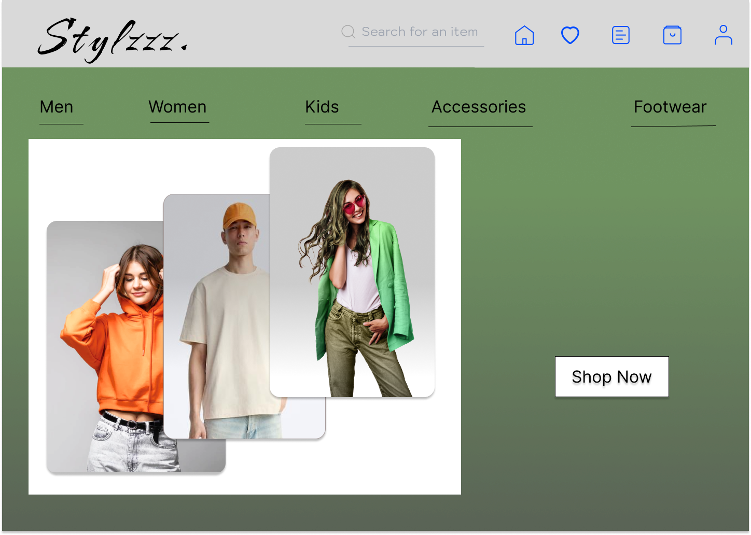

**Introduction**  
The "Stylzzz." landing page is intended for an e-commerce fashion web site, which must be aesthetically pleasing and user-friendly. The design uses a mix of familiar and unfamiliar navigation elements to promote usability and involve users effectively.

**Familiar Navigation**  
  
Familiar navigation is used to describe interface components with which users are acquainted and can easily identify. They improve the usability of the interface by taking advantage of standard design patterns.

**Implemented Familiar Navigation:**  
  
**1. Category Menu (Men, Women, Kids, Accessories, Footwear):**• Standard e-commerce category names that permit users' direct access to needed product sections.  
• Underlined text was utilized to bring clarity and to particularly mark certain links.  
• Excellent logical categorization of items facilitates rapid scanning as well as lessens mental effort.  
**2. Search Bar:**• Created at the top center, it satisfies users' expectations about search functionality location.  
• Placeholder label "Search for an item" is clear and stimulating for discovery.

**Unfamiliar Navigation**  
Unfamiliar navigation is defined as design aspects which might not be instantly familiar to all the users. Although such features would bring novelty and originality to the interface, they will also lead to causing users to acquire usage knowledge.

**Implemented Unfamiliar Navigation:**  
  
**1. Icons (Home, Cart, Login):**  
• Turning on the usage of icons in isolation from labels can be treated as unfamiliar, particularly among less educated users of e-commerce websites.  
• Even though icons are recognizable all over the globe to a certain degree, their lack of labeling might perhaps make learning more difficult for some users.  
• The minimalist design aesthetic tries to keep the interface clear but might be improved by including hover tooltips or labels in a bid to make it as clear as possible.

**Design Rationale**  
  
**Familiar Navigation:** Kindly guides users to the finding of products and minimizes effort to learn the interface. Perfect for shopping online, where product categories' usability is at the top of priorities.  
  
**Unfamiliar Navigation**: Adds an upscale and minimalistic look to the design. But soft prudence should be observed in maintaining appearances versus usability. Adding tooltips or discreet clues can enhance user experience.  
  
**Conclusion**  
  
  
The "Stylzzz." homepage contrasts new with known navigation components. The familiarity of the category navigation enhances the usability, but the minimalist icons bring a fresh design view. Future improvement can include labelling or adding tooltips to the new navigation components